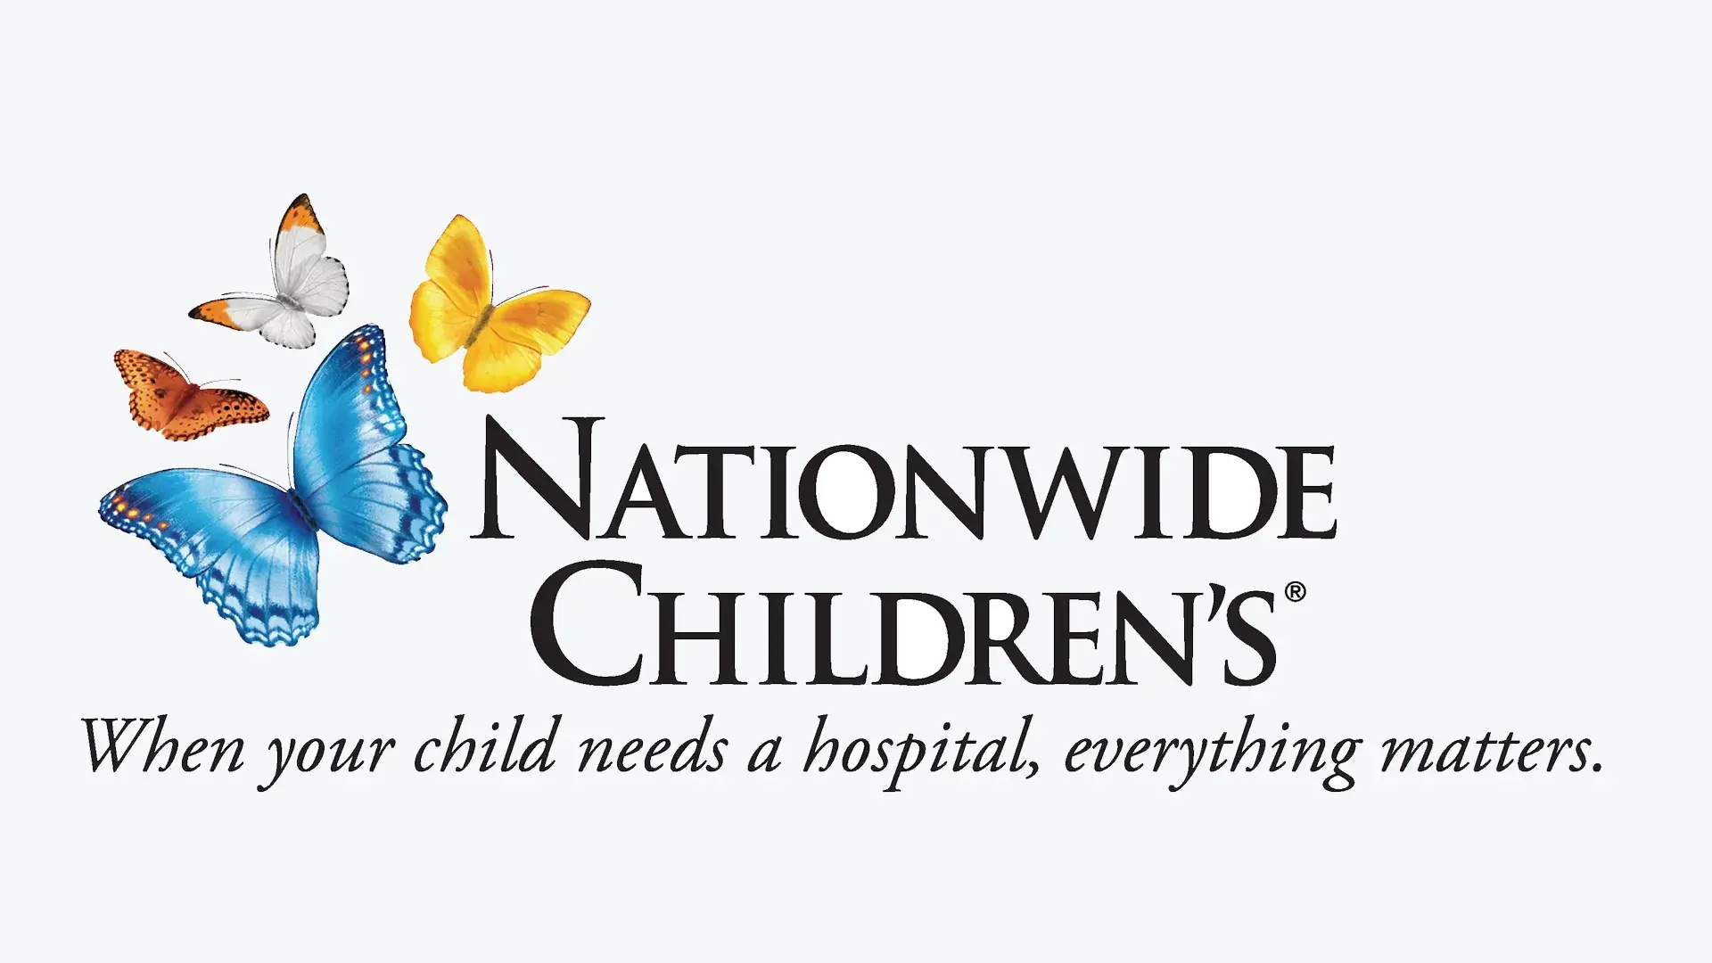

“In Warm Blood: Encouraging the Columbus Community to Transfer Mercy, One Bag at a Time”

Nationwide Children’s Hospital is a pediatric hospital and research institution headquartered in Columbus, Ohio. Ranked among the top 5 national pediatric hospitals by Forbes, Nationwide Children’s is dedicated to leaving no child behind when it comes to healthcare treatment and support. One goal that Nationwide Children’s Hospital is struggling to reach is encouraging an adequate amount of the community to make blood donations during blood donation drives. This campaign’s goal is to increase attendance to Nationwide Children’s annual Easter Blood Drive by 20%.
The primary audience would be young adult blood donors. The secondary audience would be our loyal children’s healthcare partner, Children’s Miracle Network (CMN). Since funds poured into CMN campaigns goes to Nationwide Children’s Hospital, many people who donate to CMN know about Nationwide Children’s Hospital.
The campaign’s strategy would be to convey abundant information about blood donation and highlight stories of individuals who had their lives saved thanks to donated blood. We would use tactics such as sending email newsletters telling stories of lifesaving blood donors, making Instagram infographics stressing the need for blood donations, and setting up blood donation Q&A tables at local community events so citizens feel less afraid of donating blood. Our measure of success would be the bags of blood donated at Nationwide Children’s Hospital Easter Blood Drive.

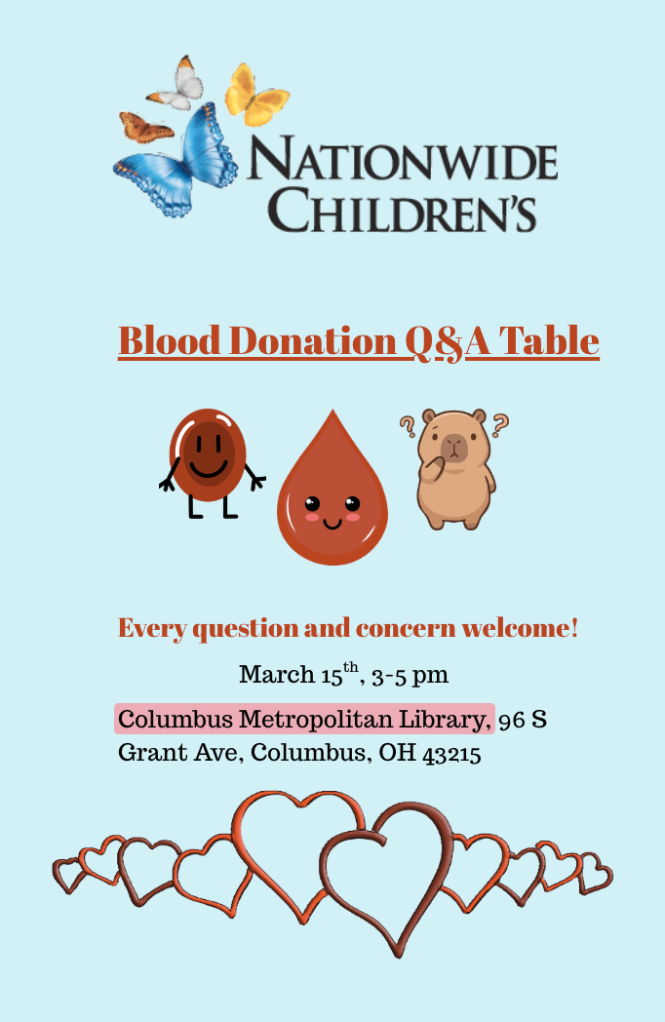
Sample Blood Donation Q&A Event Poster

