Gainesville’s Art Haven
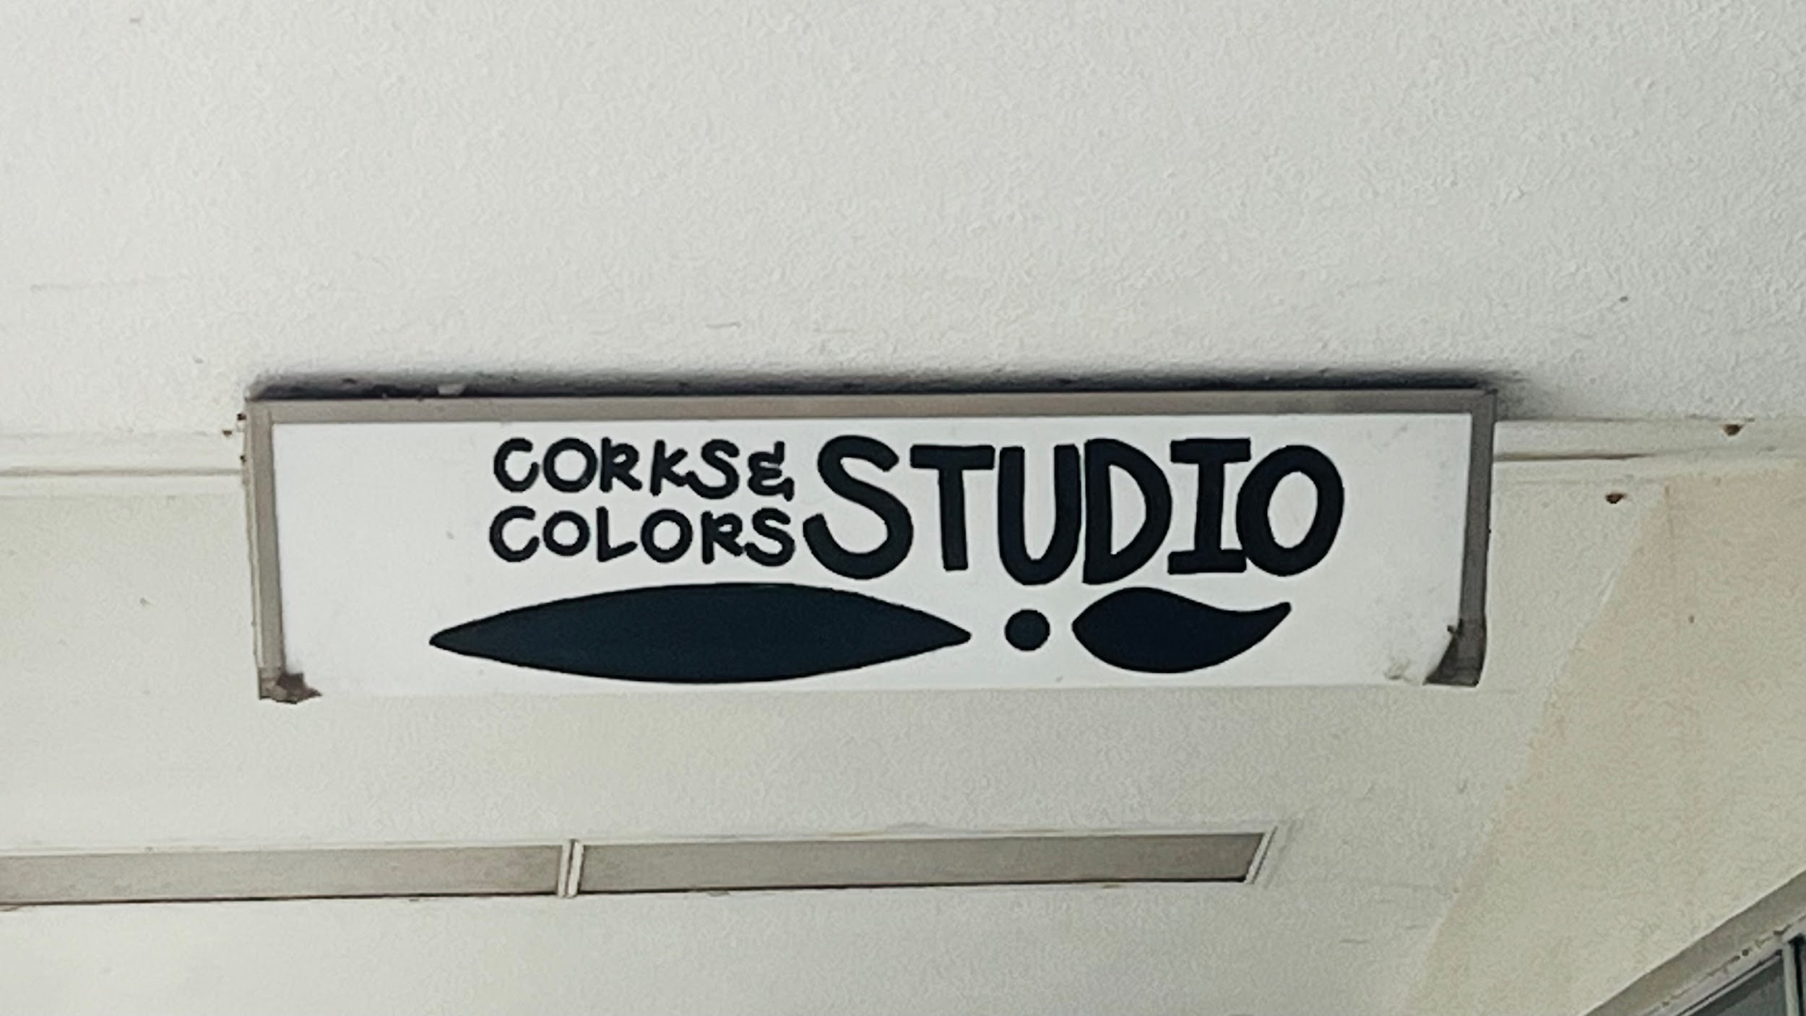
In the Westgate Regency Shopping Center, Corks and Colors Studio welcomes visitors with a beautiful window display full of ceramics and paintings. Some of these works include a painting of a dolphin leaping over a sunset beach, a rainbow cupcake sculpture, and a sapphire blue plate adorned with painted flowers. Above the shelves hang small plant pots strung by intricately tied strings. This is the place where people pay to make art and escape reality briefly. People can either walk in to create art independently, or sign up for classes (which are on the Corks and Colors website). The studio provides ample art materials for customers to utilize. Corks and Colors teaches wheel pottery and acrylic painting, and welcomes all ages and experiences. The business is open from Wednesday to Sunday. On Wednesdays and Sundays, the studio runs from 12 pm to 6 pm, while all the days in-between go from 12 to 9 pm.
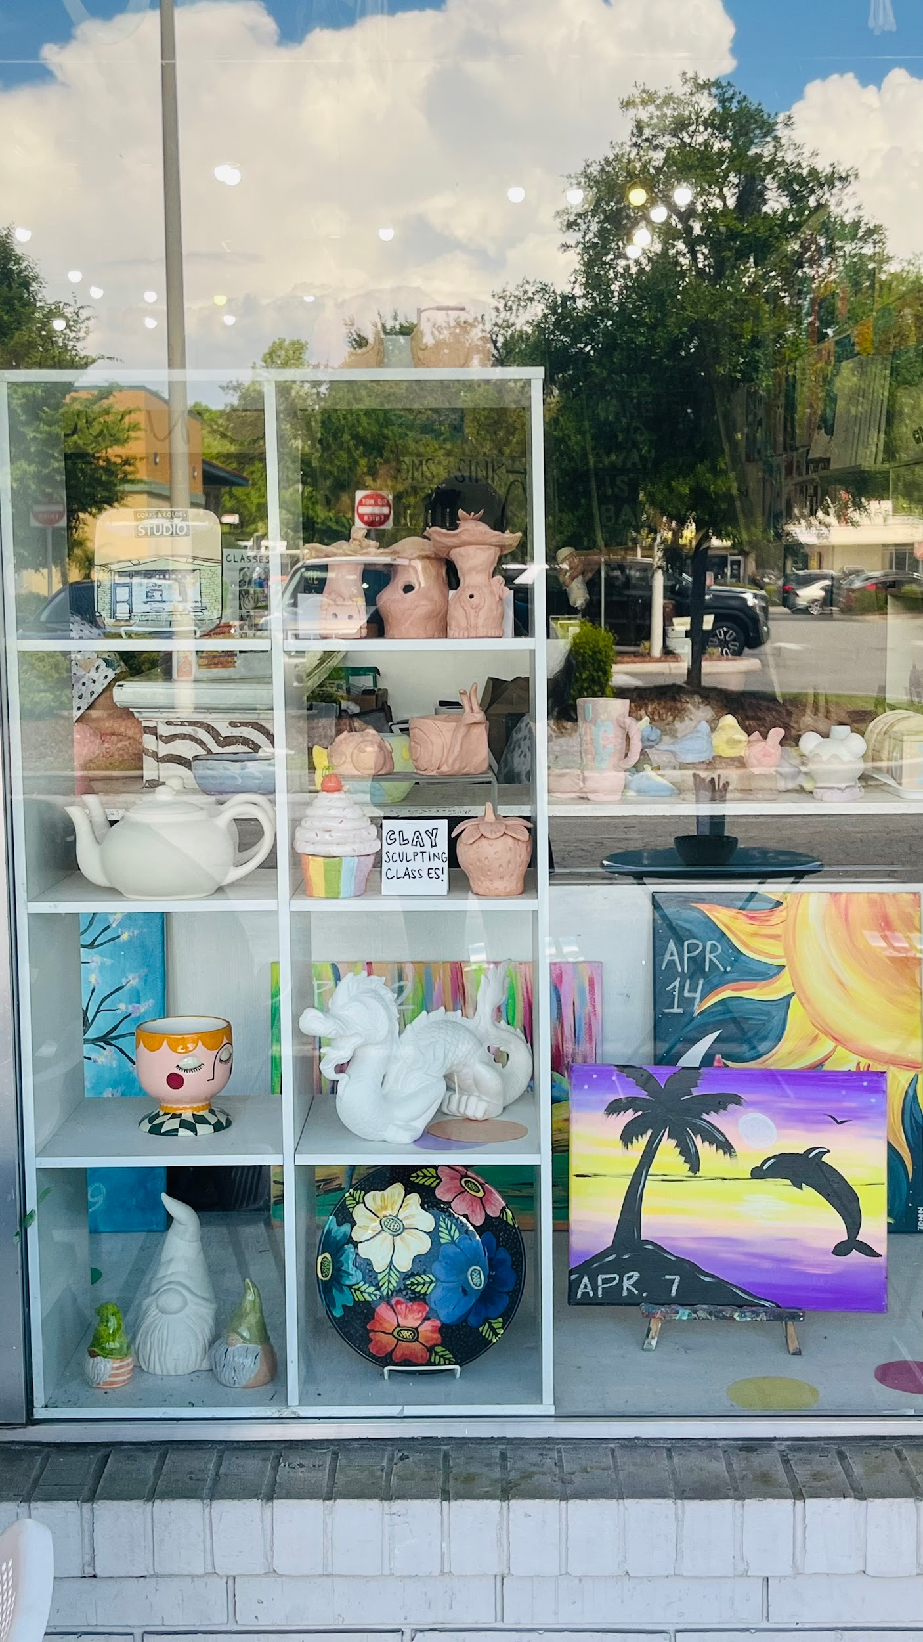
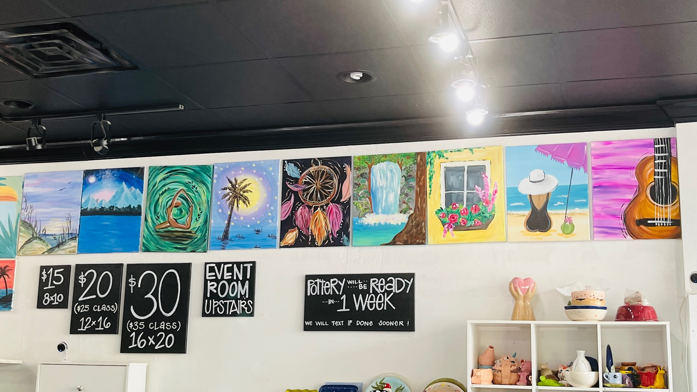
Corks and Colors was founded in 2010 by a woman named Erika. Erika grew up in Gainesville and wanted to give people in her home city a place to unlock their creativity. When one steps into Corks and Colors, they realize that nearly every space on the studio walls is taken by a colorful painting. Each table where customers can use is equipped with a tub full of paintbrushes, a bowl of water, and a small menu offering drinks (which can be ordered at a desk). A black and white staircase that reads “To practice any art no matter how well or badly is a way to make your soul grow.” The stairs lead customers to a second floor with extra art tables.
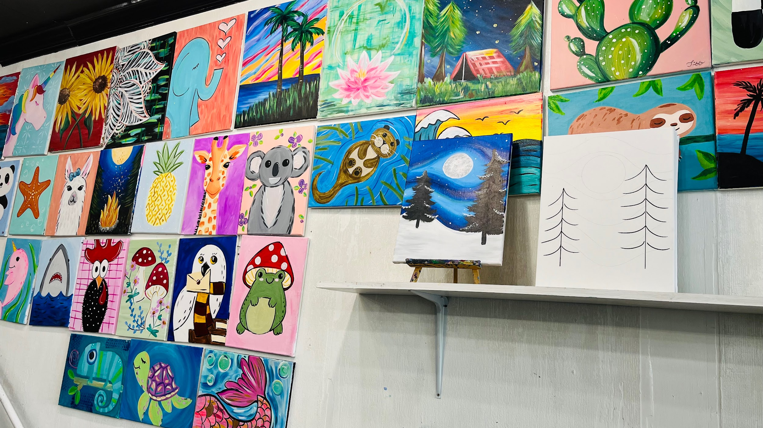
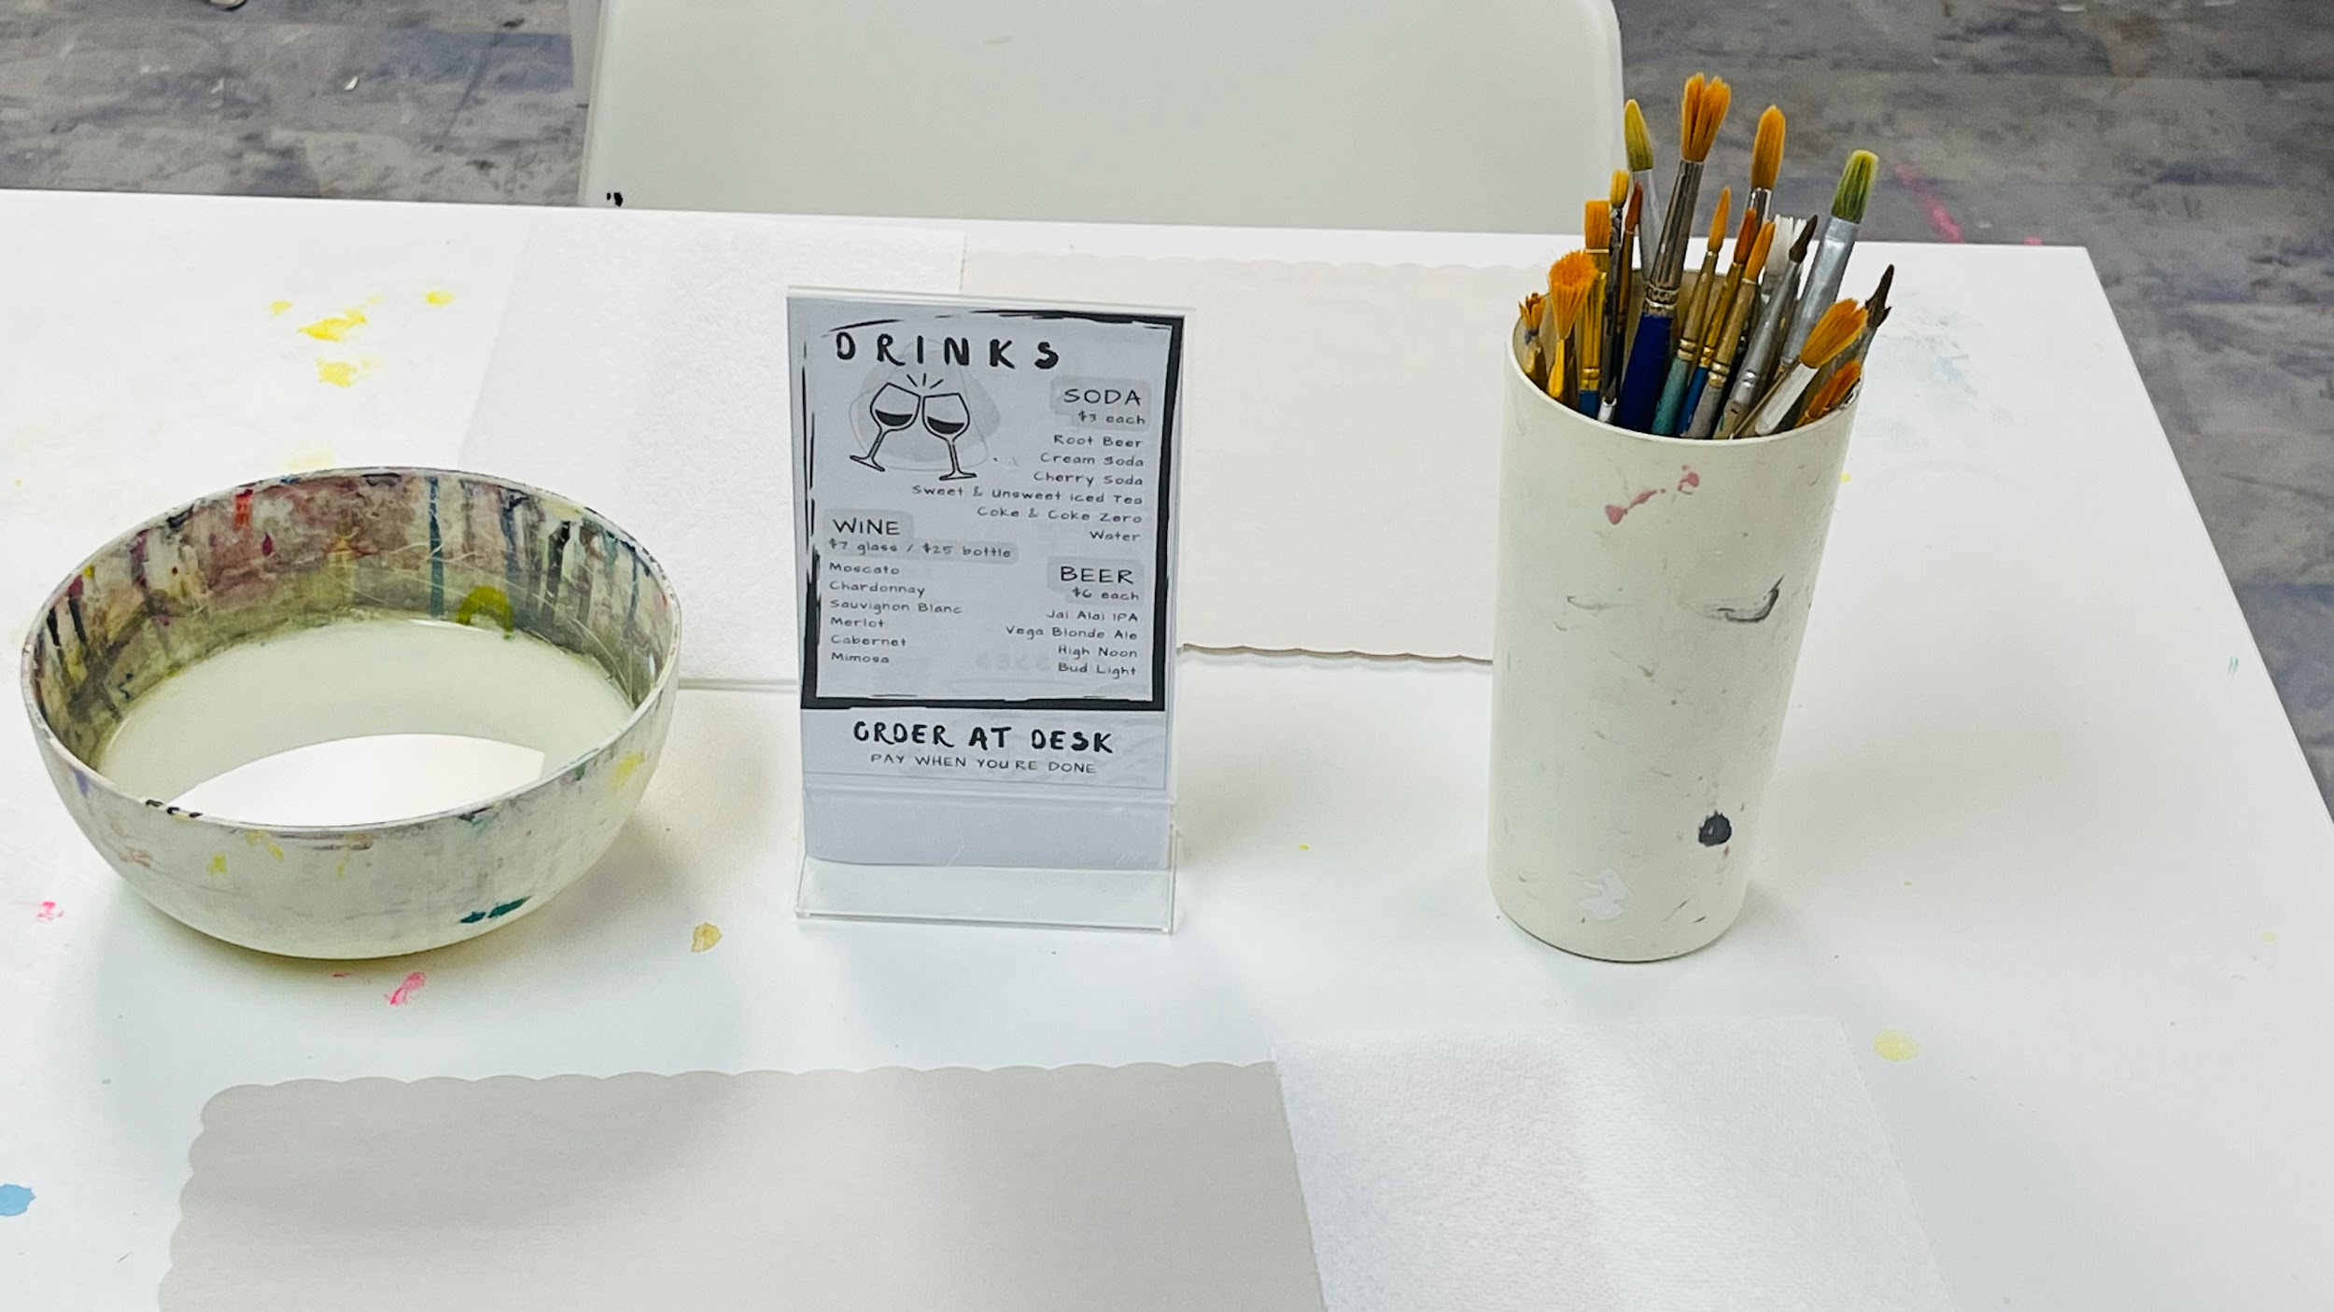
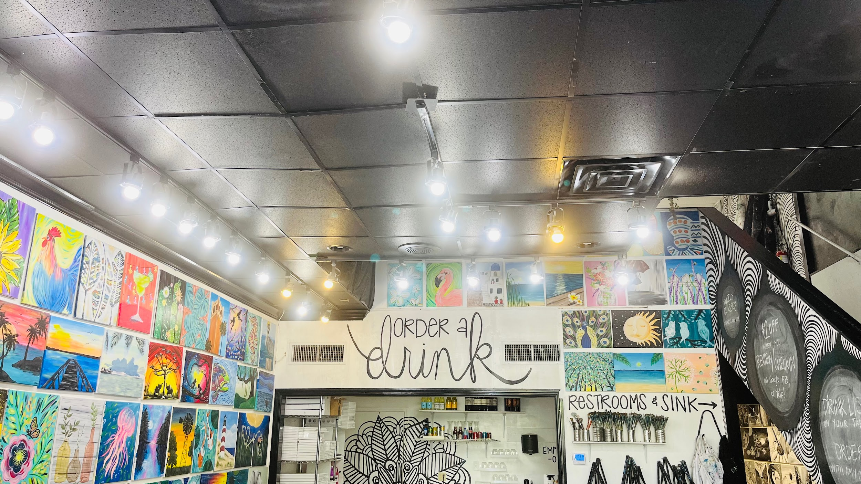

Hailey, a front-desk cashier and pottery instructor for Corks and Colors, has been working at the business since December 2023. She picked up the career due to the creative aspect and her love for teaching others pottery. When asked why she believes so many people find solace in making art (as Corks and Colors often bustles with customers), she stated that art is “...a creative outlet and it allows you to turn off your mind. You have complete freedom to do whatever you want.” Eliana is an employee who’s responsible for loading and stocking art materials. Much like Hailey, she desired to work at the studio because of pure passion for art and pottery. “I think people find comfort in art because it’s a way to express yourself…I think that with art, it gives you a chance to say and feel things without necessarily having to talk about them.” She expressed gratitude for Corks and Colors, saying “...I’m proud of the amount of art that’s made here every day, because [in] so many places, you come in and you really don’t get to express yourself.”
What differentiates Corks and Colors from an average art studio? An interviewed customer stated that they would definitely recommend Corks and Colors for individuals that enjoy art, as the studio has cordial employees and many options in customizing one’s art. She and another customer (they both asked to remain anonymous) described the studio’s environment as “relaxing, friendly, and fun.” A third customer, who first visited Corks and Colors thanks to her UF sorority retreat, says “It’s a really fun atmosphere and everyone that works here is really nice.” Like the previous two customers interviewed, she viewed Corks and Colors’ surroundings as “relaxing.” It seems that Corks and Colors’ commitment to making customers feel as comfortable as possible has played a significant role in its success. Eliana adds that the studio is “...more special that it’s not owned by a large company.”
